

YOUTH 2025-2026 – SECONDARY SCHOOL DIVISION

- COMPETITION OVERVIEW
Teams (School teams) will be organized as Boys or Girls 7-a-side squads, competing on approximately a half-size pitch. A minimum of 5 players is required to start a match.

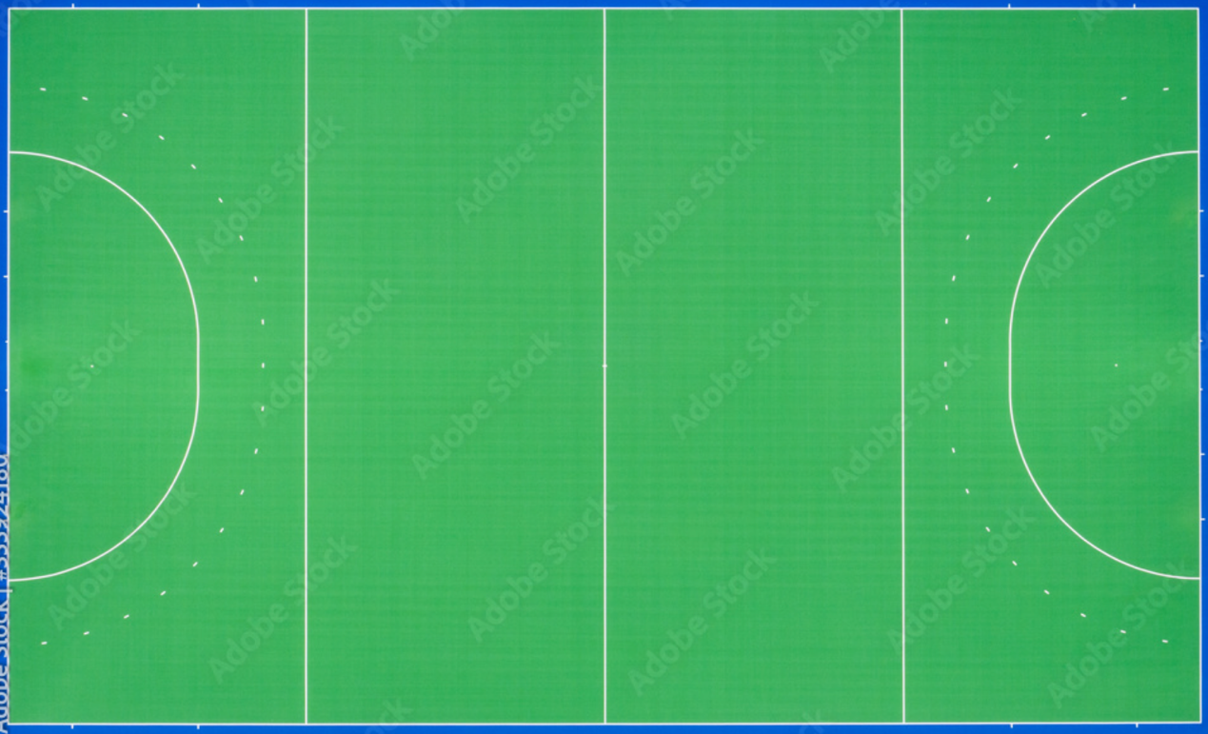
scoring zone

Pitch B

scoring zone

scoring zone

Pitch A

scoring zone

To ensure flexibility and maximize playing time, each team may register up to twelve (12) players for a single match. For full details, please refer to Item 2: Competition Rules.
The competition format will be determined by the total number of participating teams. The event will either be conducted as a full round-robin or a round-robin group stage followed by knockout matches. Games will consist of two 10-minute halves with a 3-minute halftime, or alternatively, a single 15-minute straight period.
The primary aim of the event is to provide players with maximum match experience. All games will operate under FIH guidelines and HockeyHK rules, with minor amendments in place to ensure player safety.

- COMPETITION RULES
1. Match Duration: A match consists of two halves of 10 minutes each, with a 3-minute interval, or a single continuous 15-minute period.
2. Team Composition: A match is played between two all-girl or all-boy teams. Each team must have at least five and no more than seven players on the court at any one time.
3. Goalkeepers: While not mandatory, teams are encouraged to field a goalkeeper. The goalkeeper does not count toward the seven-player limit, meaning a team may have eight total players on the court if a goalkeeper is used. For safety, goalkeepers must wear full protective equipment.
4. Scoring a Goal: A goal is scored when the ball is played by an attacker from within their attacking zone—defined as 10 meters from the goal line—and passes completely over the goal line and under the crossbar.
5. Playing the Ball: The ball may be pushed or slapped. Hitting and lifting the ball above knee height are permitted, provided it is not deemed dangerous by the umpire.
6. Restart Procedures (Free Hits, Centre Pass, and Play-ins):
6.1 The ball must be stationary.
6.2 All players other than the one taking the hit must be at least 4 meters from the ball.
7. There will be no penalty corners or penalty strokes awarded.
8. Awarding a Challenge: A challenge (one-on-one opportunity against the goalkeeper) will be awarded:
8.1 For an action preventing a certain goal (e.g., a foot on the goal line).
8.2 For a deliberate foul by a defender within their own attacking half.

9. Procedure for Taking a Challenge
a. All players other than the challenger and the defender must position themselves beyond the centre-line.
b. The ball is placed on the designated goal shooting line (marked as a dotted line in front of each goal).
c. The challenger must begin behind the ball.
d. The defender must stand with both feet on or behind the goal-line and may not leave it until the ball is in play.
e. The umpire will signal the start with a whistle once both the challenger and defender are correctly positioned.
f. Play may begin only on the whistle. Neither the challenger nor the defender may unnecessarily delay the start.
g. The challenger may play the ball but may not attempt a shot on goal until the ball has travelled at least 4 metres.
h. The defender may move once the challenger has played the ball.
i. After the challenger plays the ball, normal play resumes and all other players may re-enter the play from beyond the centre-line.

10. Personal Penalties
a. For any offence, the offending player may receive one of the following sanctions:
i) A caution (indicated verbally by the umpire).
ii) A temporary suspension for 1 minute of playing time (indicated by a green card). The suspended player may not be replaced.
iii) A temporary suspension for a minimum of 2 minutes of playing time (indicated by a yellow card). For repeated offences or serious physical foul play, a 4-minute suspension (also indicated by a yellow card) may be awarded. For the duration of any temporary suspension indicated by a yellow card, the offending team must play with one fewer player on the court.
iv) A permanent suspension from the current match (indicated by a red card). For the remainder of the match, the offending team must play with one fewer field player. A personal penalty may be awarded in addition to any other applicable penalty.
b. Temporarily suspended players must remain in a designated area until permitted by the suspending official to re-enter play.
c. Temporarily suspended players are permitted to rejoin their team during intervals after which they must return to a designated place to complete their suspension.
d. The intended duration of a temporary suspension may be extended for misconduct by a player while suspended.
e. Permanently suspended players must leave the court and its surrounding area.
f. If a player receives a personal penalty in conceding a challenge, the timing of the penalty does not start until the challenge is completed (irrespective of the outcome)

III. Safety and Equipment Regulations
Dangerous conduct will not be tolerated. In cases of repeat offences deemed by the umpire to be extremely dangerous, the player may face suspension from the tournament.
All players are required to wear appropriate shin guards and mouth guards. Short soccer-style guards are not acceptable. Players without this mandatory equipment will not be permitted on the pitch.

While not compulsory, hockey shoes are recommended, as they provide superior protection compared to standard running shoes.

